**Mid-Term Task**

**Part I**

1. Host a static website on Blob Storage: build and deploy a static Hello World website to Azure Storage.
2. Verify that the default web page has the Hello World! page.
3. Provide the steps and results.

We start off by creating a new storage account by searching for storage accounts in the azure portal -> Storage accounts. Input the required information and press on Create.

This is the storage account after deployment:

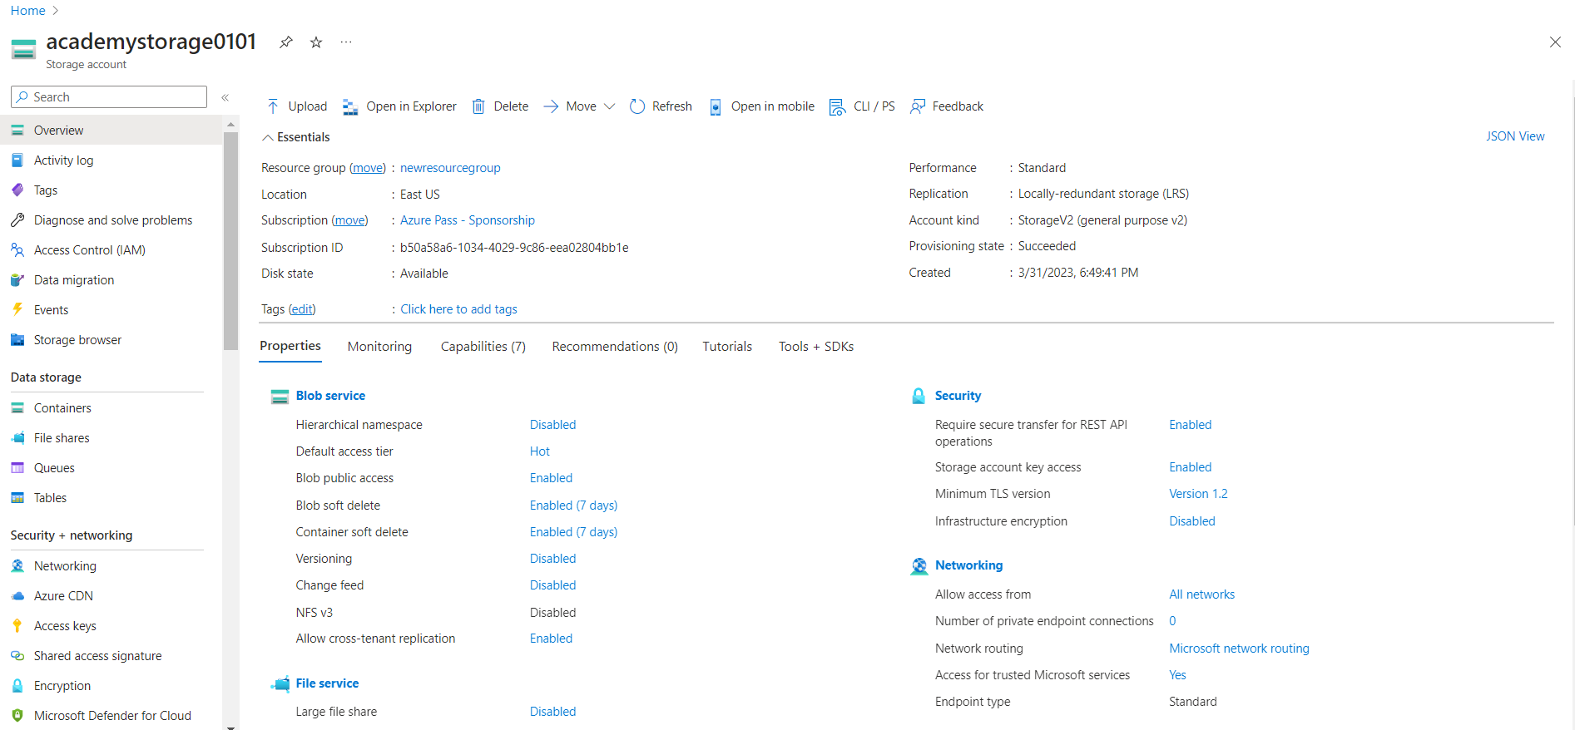

To enable the static website, we have to navigate from the left panel of storage accounts -> data management -> and select Static website. We press Enabled, and input the following information in the 2 fields and Save the changes:

We then are presented with the Primary endpoint link, which we have to save/copy as it will be used later on to access the website.

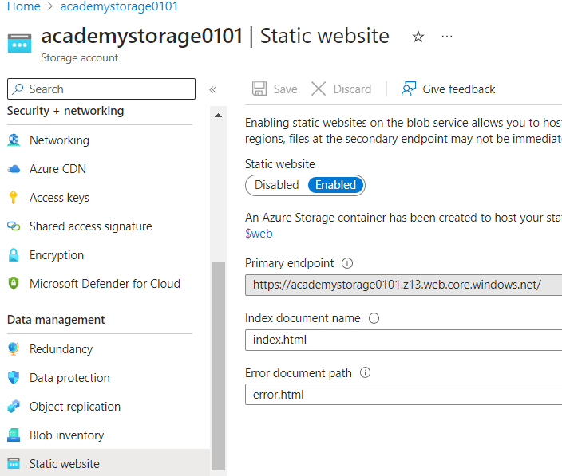

The blob service can be located in Data Storage -> Containers -> select $web

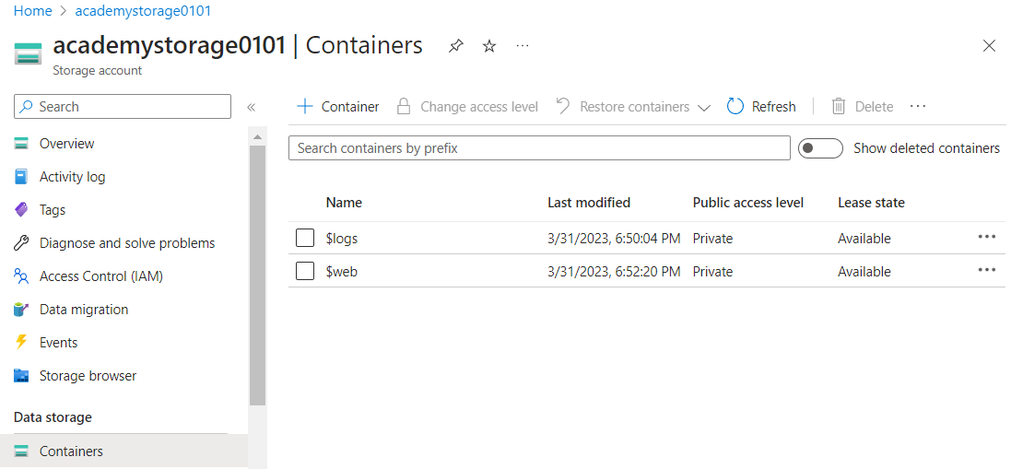

Next, we will use a simple html code (and save it to the desktop so we can later upload it) so the required text “Hello World!” can be displayed.

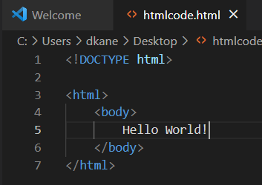

And we upload it on the $web page.

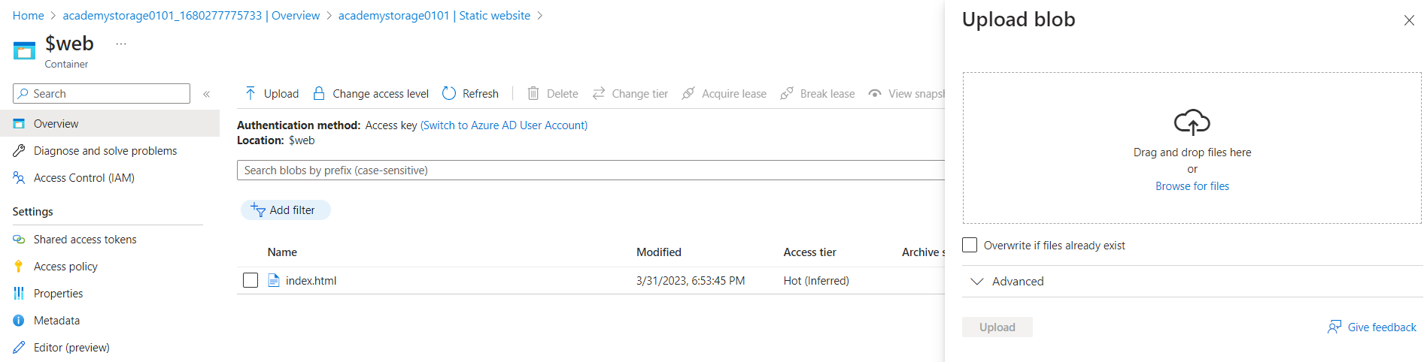

On the final step, if we go back to the default page, we can see the correct text displayed:

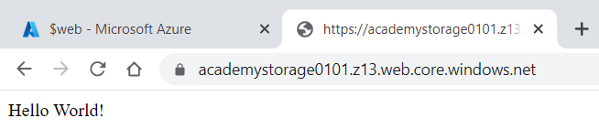

**Part II**

In this exercise we will setup a Linux based web server and will deploy a web page on it.

1. Create a Virtual Network where you will deploy your Linux Based Web Server.

2. Modify the network security group for your virtual machine that will allow you to remotely manage your machine only from your local machine and nowhere else.

3. Create a Linux Virtual Machine that will be your Web Server which is publicly available for web publishing (not SSL) only from your machine and nowhere else.

4. Connect to the VM.

5. Install Apache Web Server.

6. Deploy the “Hello World” web page.

7. Provide Testing from your cellphone.

8. Provide the steps and results.

1. Create a Virtual Network where you will deploy your Linux Based Web Server.

We start off by creating the virtual network from the Azure portal – searching for Virtual networks -> Create button. We fill in the required information and create it:

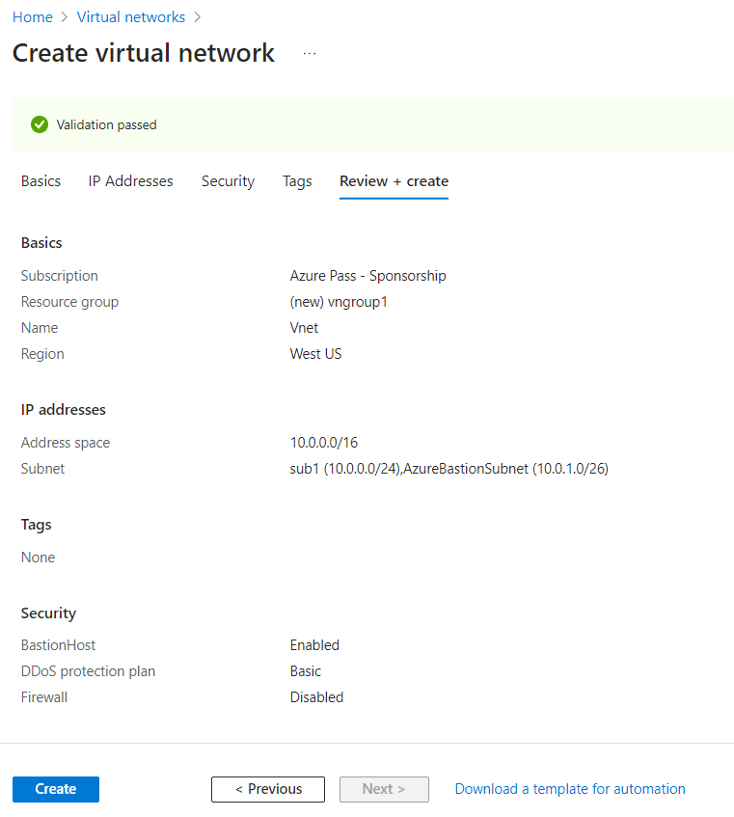

2. Modify the network security group for your virtual machine that will allow you to remotely manage your machine only from your local machine and nowhere else.

Here, we search for Network security groups -> Click +Create to create a new one and 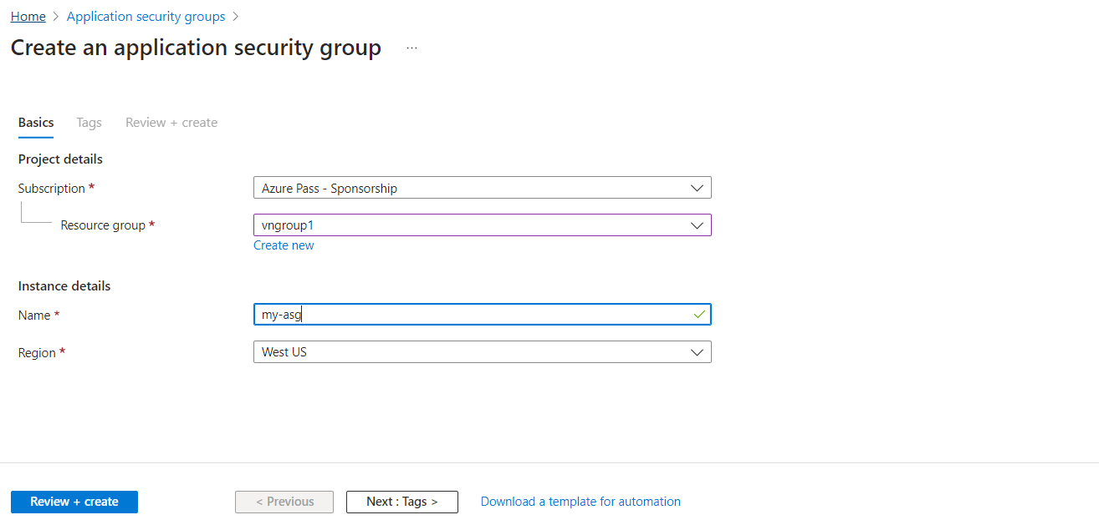

We got back to our Virtual machines -> select our machine -> on the left panel under Settings -> we select Networking and configure our security group.

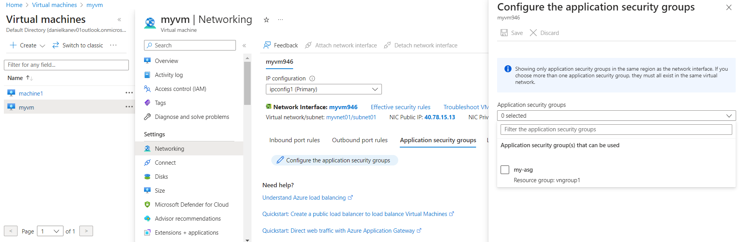

On the newly created network security group -> Settings -> We add an Inbound security rule (+Add) and select our destination, change port ranges to 22 and TCP Protocol

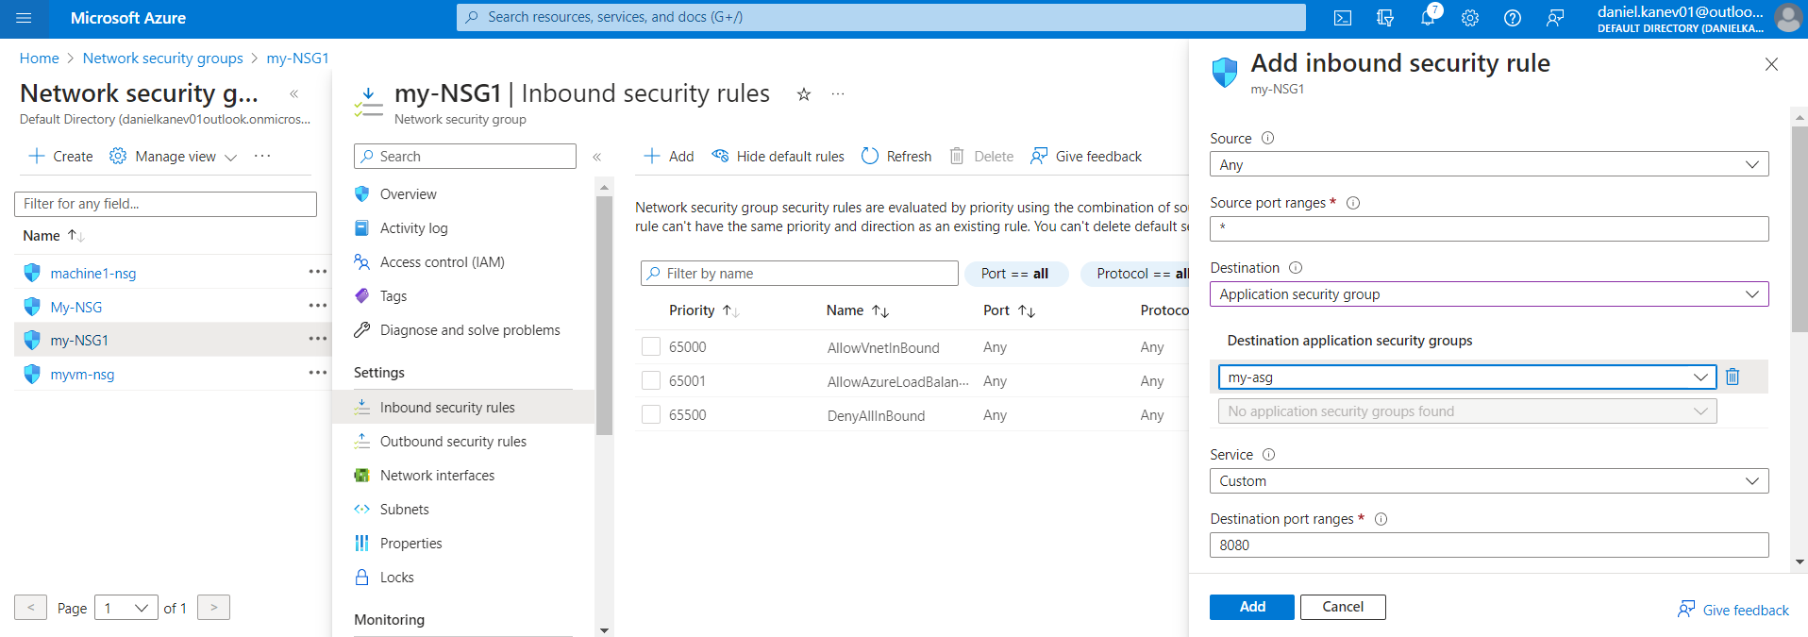

Back on the virtual network we set our subnet rules:

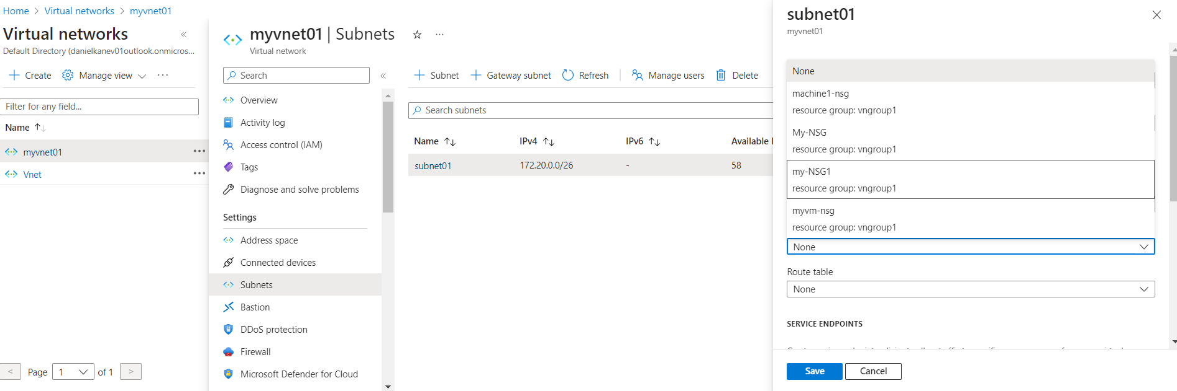

3. Create a Linux Virtual Machine that will be your Web Server which is publicly available for web publishing (not SSL) only from your machine and nowhere else.

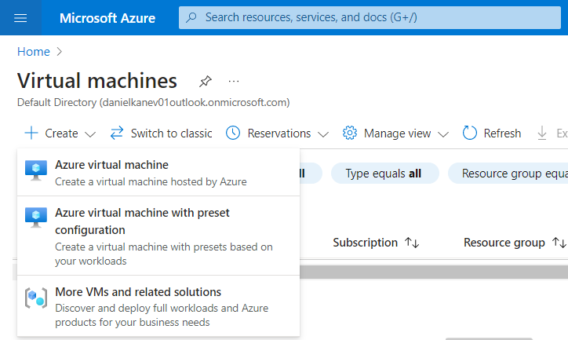

Fill in the information and create it:

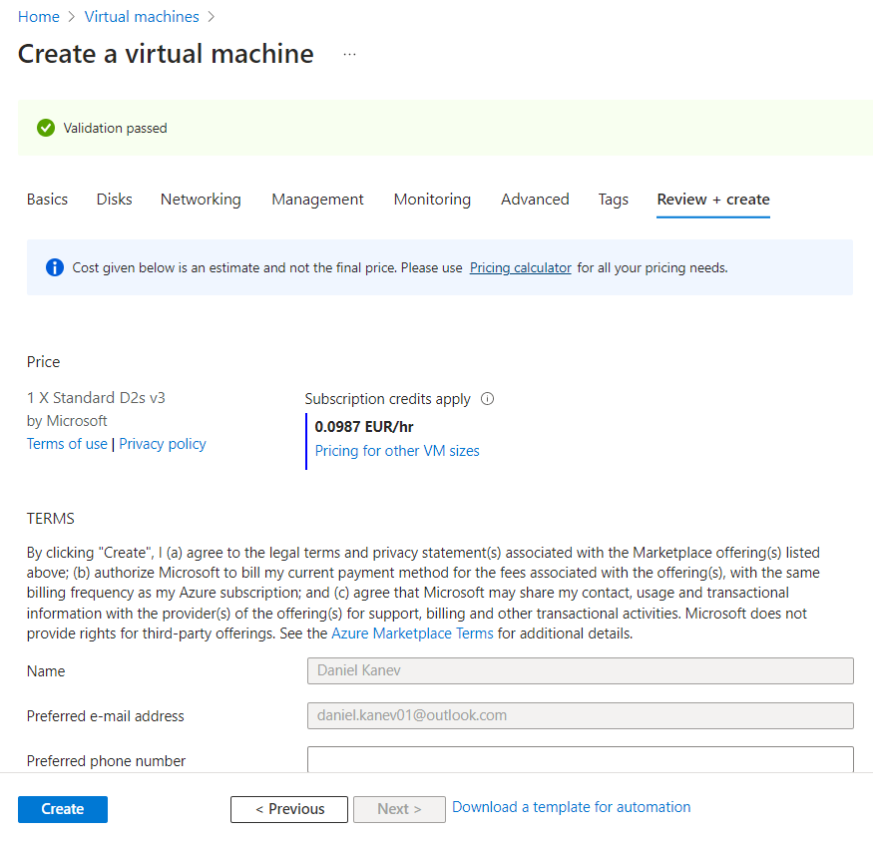

And the virtual machine home screen:

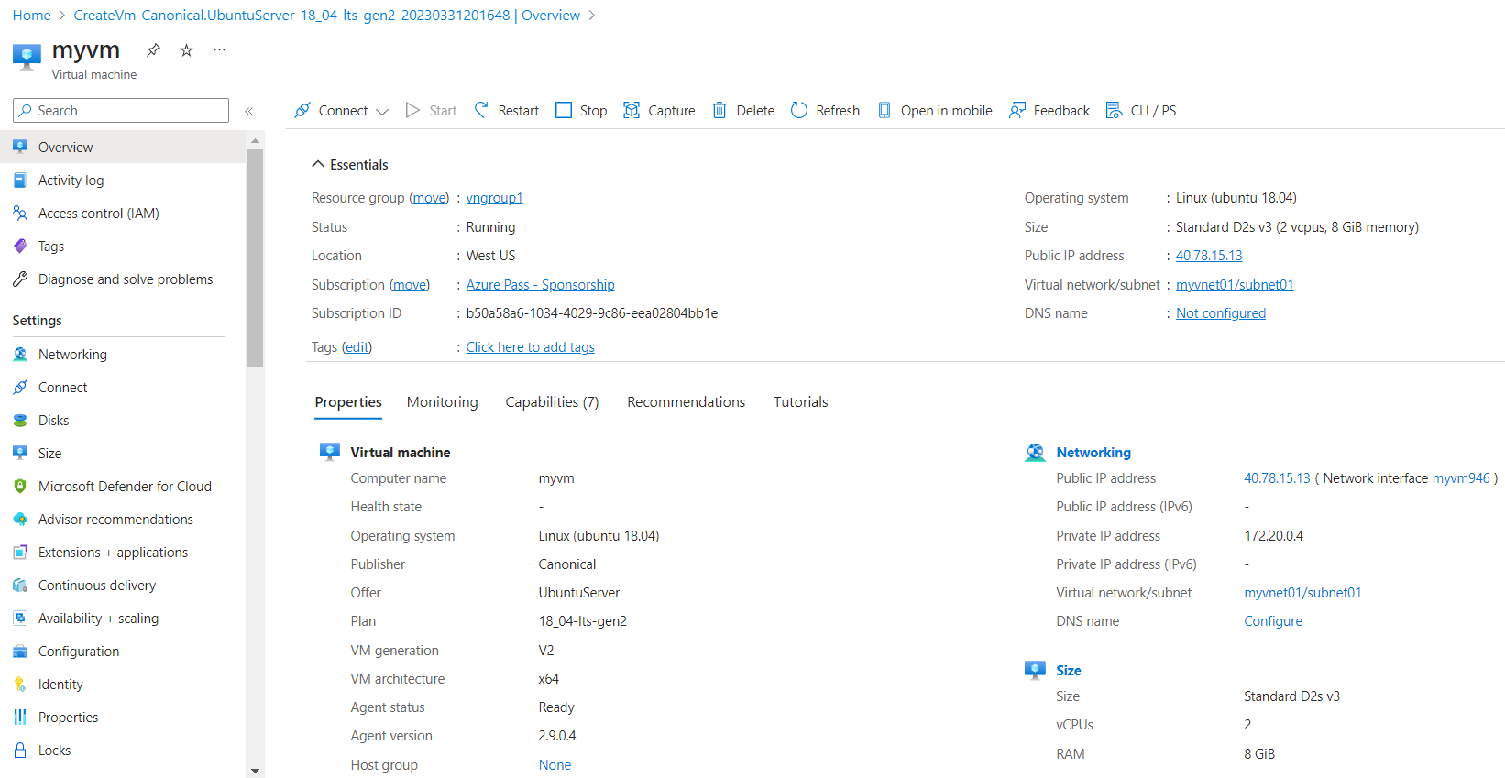

4. Connect to the VM.

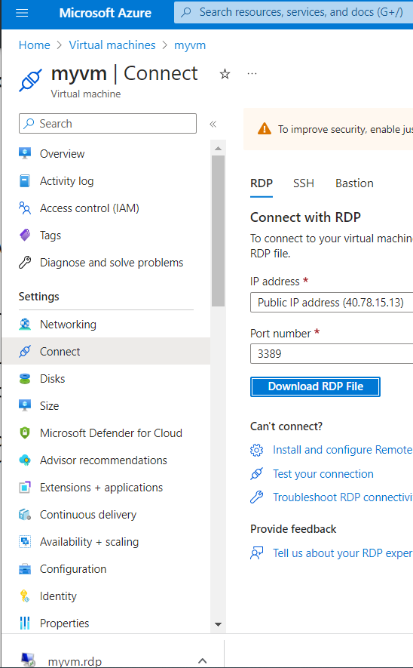

5. Install Apache Web Server.

To install the apache web server, we are using the following command:

sudo apt-get install apache2 in the terminal